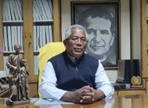Message From Author Of Snehalaya Charitable Trust Snehalaya services in the city of Guwahati is very close to the heart of the Don Bosco Fathers, Brothers and Sisters. I am delighted to see the various creative interventions by Snehalaya to help the boys and girls to develop physically, intellectually, emotionally and spiritually.
NEWSLETTER NO: 34
CWহা ধািৱন
SNEHA DHWONI
________________________________
An Official Newsletter of Snehalaya Charitable Trust
Guwahati-781001, Trust Deed No.4223/02
APRIL-JUNE 2023
I am extremely happy to see you all grow up in a family atmosphere, so cheerfully, without fear and want, under the loving care of the fathers and sisters and staff. As Don Bosco among you, I give you my blessings.
Kindly make full use of all the opportunities you get in the 'House of Love' and the Child Friendly Guwahati programme. I am happy that Fr. Lukose Cheruvalel is back in Snehalaya. He will lead Fr Mackley, Fr Prasad and Fr Sebastian, and all the Sisters and staff to work for the best interests of children in need of care and protection. We shall overcome all obstacles with faith in God.

Fr. Janaurius S Sangma (Provincial)
Salesians of Don Bosco North East India
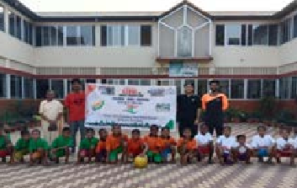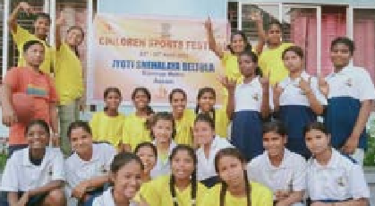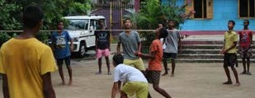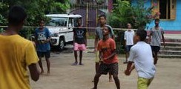Guwahati-781001 Assam
Sports Festival for Snehalaya Children
From 23rd April to 25th April, the Snehalaya homes were filled with excitement as they organized a Sports Festival as part of the Azadi ka Amrit Mahotsav celebrations across India. Children from all five homes participated enthusiastically in various sporting events, fostering a sense of healthy competition and team
spirit. The grounds echoed with cheers and
applause as the
young athletes showcased their skills in athletics, volleyball,
cricket, and more. The Sports Festival not only promoted physical fitness but also encouraged camaraderie and a sense of belonging among the children, making it a memorable celebration of sportsmanship.
1

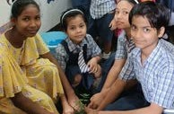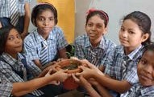Celebrating the World Environment Day
On 5th June, the children of Snehalaya came together to celebrate World Environment Day with great enthusiasm. With a deep sense of responsibility towards the planet, they organized a range of activities to raise awareness about environmental conservation. The children actively participated in tree plantation drives, emphasizing the importance of green spaces and the need to protect and preserve nature. They also engaged in workshops and interactive sessions to
learn about sustainable practices such as waste management, recycling,
and reducing carbon footprint. Through art and craft projects, they creatively expressed their love for the environment and showcased the beauty of nature. The celebration of World Environment Day at Snehalaya was a powerful reminder of the children's commitment to a greener and more sustainable future, inspiring others to join their efforts in preserving the planet for generations to come.

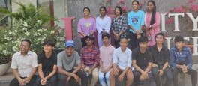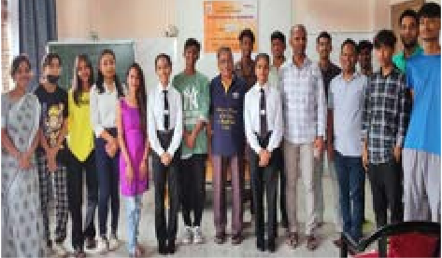After-care Youth Meet
On 18 May, an impactful After-care Youth meet was organized for children who were embarking on the journey of social reintegration. The event aimed to provide them with guidance, support, and a sense of community as they transitioned into independent lives. It brought together young individuals who had previously been in institutional care, creating a platform for them to share their experiences and challenges. The meet offered workshops, counseling sessions, and skill-building activities to equip
them with essential life skills, boost their self-confidence, and empower them to navigate the next chapter of their lives. It was a heartwarming gathering, fostering a sense of belonging and reminding the young participants that they were not alone on their path to social reintegration.

A Day-Out for the Post-Matric Boys and Girls
An exciting day-out awaited the matric pass boys and girls of Guwahati as they embarked on a memorable trip to the City Centre. Brimming with anticipation and joy, they explored the vibrant cityscape, immersing themselves in the hustle and bustle of urban life. The outing provided an opportunity for the young graduates to celebrate their achievements and unwind
after the rigorous academic journey. They indulged in
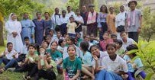shopping, watched movies, and relished delicious meals, creating unforgettable memories with their peers. The day-out not only served as a well-deserved break but also inspired the students, motivating them to dream big and strive for success in their future endeavors.
Bihu Celebrations in Snehalaya Homes
On 14th April 2023, all the children of Snehalaya filled the air with joy and laughter as they celebrated Bihu. Dressed in vibrant traditional attire, they danced gracefully to the beats of the dhol and played melodious tunes. Their radiant smiles and synchronized movements showcased the spirit of unity and cultural pride during this auspicious festival.
22

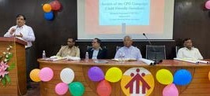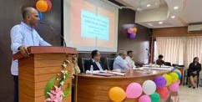CFG Review Meet and Blessing of the Renovated Office
A momentous occasion took place as the Child Friendly Guwahati (CFG) program conducted a review meeting, reflecting on its transformative journey over the past 10 years from 2013 to 2023. The meeting served as a platform to assess the program's accomplishments in promoting child rights, education, and well- being in the city of Guwahati. Participants shared success stories, discussed challenges, and outlined future plans to further enhance the program's impact.

Adding to the significance of the day, the renovated office of the CFG program was blessed Rev.Fr. Janauries S. Sangma, the Provincial of ING symbolizing a fresh chapter of growth and commitment to the cause. The event united stakeholders, volunteers, and beneficiaries in a shared vision of creating a safer, inclusive, and nurturing environment for every child in Guwahati.

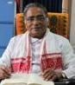Snehalaya Welcomes Fr. Lukose Cheruvalel & Fr. Mackley Gomes
Amidst a mix of emotions, the Snehalaya community came together on July 02, 2023 in Snehalaya, Centre For Child Rights to extend a warm welcome to the new Rector, Fr. Lukose Cheruvalel and to Fr. Mackley Gomes, the vice Rector. At the Same time the Community bid a grateful farewell to the outgoing Rector, Fr. Thomas Anikuzhikattil and to vice Rector Fr. Martin R Marak. The occasion was filled with gratitude and appreciation for the tireless efforts and leadership of Fr. Thomas which

Fr. Thomas Anikuzhikatyl

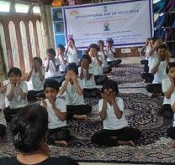Fr. Martin R Marak
Observance of Yoga Day
On 21st June, the children of Snehalaya across all five homes came together to observe Yoga Day. The day began with a sense of tranquility as the children gathered in open spaces, ready to embark on a journey of mindfulness and physical well-being. Under the guidance of skilled instructors, they practiced various yoga asanas, focusing on deep breathing and gentle movements. The atmosphere was filled with calmness and concentration as the children embraced the ancient practice of yoga, experiencing its numerous benefits firsthand. The observance of Yoga Day not only fostered a sense of discipline and self- awareness but also promoted a healthy lifestyle among the children, empowering them with tools for relaxation and stress management. It was a beautiful day of harmony and unity, celebrating the union of body, mind, and spirit through the practice of yoga.
3
were acknowledged and celebrated. Simultaneously, the arrival of Fr.
Lukose brought a sense of anticipation and fresh beginnings. The community embraced the transition with open arms, expressing their eagerness to work alongside Fr. Lukose and continue the journey of growth and progress. It was a poignant moment of reflection and anticipation as the community bid farewell to one leader and embraced another, united in their shared commitment to the values and mission of " Snehalaya". Fr. Lukose is the Founder of Snehalaya, "A House Of Love".
Fr. Lukose Cheruvalel

Fr. Mackley Gomes

Commence of Dance,Music & Arts Classes
Starting from the month of May 2023, a new chapter of creativity and self-expression began for the children of Snehalaya as they eagerly embarked on music, dance, and art classes. The halls and c‘ lassrooms buzzed with excitement as talented instructors introduced the children to the world of melodies, rhythmic movements, and artistic techniques. The children embraced the opportunity with open hearts and minds, discovering their innate talents and exploring different forms of artistic expression. The classes not only nurtured their artistic abilities but also served as a medium for self-discovery, confidence-building, and emotional well-being. The commencement of music, dance, and art classes added vibrant colors and harmonious melodies to the lives of Snehalaya children, creating a platform for their artistic growth and fostering a deep appreciation for the arts.

"Humanity should be our Race, Love Should be our Lives"

Support us by making a small contributioin for the unpriviledged Children.
Your Little Help can go a long Way.

Our Bank Details

Account Name: SNEHALAYA Account Number: 11820100110822
IFSC CODE: FDRL0001182 MICR CODE: 781049002
BANK NAME: FEDERAL BANK

Thank you

_______________________S__N__E_H__A_L__A_Y__A__C__H__A_R__IT__A_B__L_E__T__R_U__S_T______________________
DonBosco, Pan Bazar,Gate-no.1 Guwahati-Kamrup ,Assam-781001,India
+91-0361 2738064/2960089(O), +91-9435198236(M), +91-9492267903(M)
Email:- snehalaya.adm@gmail.com(Administrator), snehalaya.miss@gmail.com(Office) snehalaya.ghy@gmail.com (Director)
Website: www.snehalaya.co.in/donboscosnehalaya.com

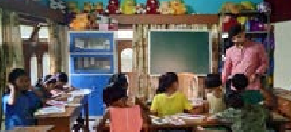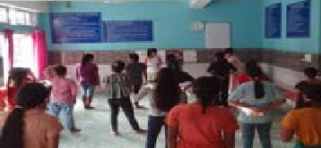Snehalaya Centre fo child rights snehalaya.co.in/donboscosnehalaya.com
snehalaya_ghy
4

